**SE3032 – Graphics and Visualization Lab 04**

**IT23226128 – D.M.D.G.B.Seneviratne**

# Activity 01

#*define* *GL_SILENCE_DEPRECATION*

#*include* <GLUT/glut.h>

#*include* <OpenGL/gl.h>

#*include* <OpenGL/glu.h>

#*include* <stdlib.h>

void *createCube*() {  ***// Clear the color buffer***

*glClear*(GL_COLOR_BUFFER_BIT);

***// Back face (Green)***  *glColor3f*(0.0, 1.0, 0.0);

*glBegin*(GL_POLYGON);

*glVertex3f*(-0.2, 0.0, -0.4); *glVertex3f*(-0.2, 0.4, -0.4); *glVertex3f*(0.2, 0.4, -0.4); *glVertex3f*(0.2, 0.0, -0.4); *glEnd*();

***// Left face (Blue)***  *glColor3f*(0.0, 0.0, 1.0);

*glBegin*(GL_POLYGON);

*glVertex3f*(-0.4, -0.2, 0.0); *glVertex3f*(-0.4, 0.2, 0.0); *glVertex3f*(-0.2, 0.4, -0.4); *glVertex3f*(-0.2, 0.0, -0.4); *glEnd*();

***// Right face (Blue)***  *glColor3f*(0.0, 0.0, 1.0);

*glBegin*(GL_POLYGON); *glVertex3f*(0.0, -0.2, 0.0); *glVertex3f*(0.0, 0.2, 0.0); *glVertex3f*(0.2, 0.4, -0.4); *glVertex3f*(0.2, 0.0, -0.4); *glEnd*();

***// Top face (White)***  *glColor3f*(1.0, 1.0, 1.0);

*glBegin*(GL_POLYGON);

*glVertex3f*(-0.4, 0.2, 0.0); *glVertex3f*(0.0, 0.2, 0.0); *glVertex3f*(0.2, 0.4, -0.4); *glVertex3f*(-0.2, 0.4, -0.4);

*glEnd*();

***// Bottom face (Yellow)***  *glColor3f*(1.0, 1.0, 0.0);

*glBegin*(GL_POLYGON);

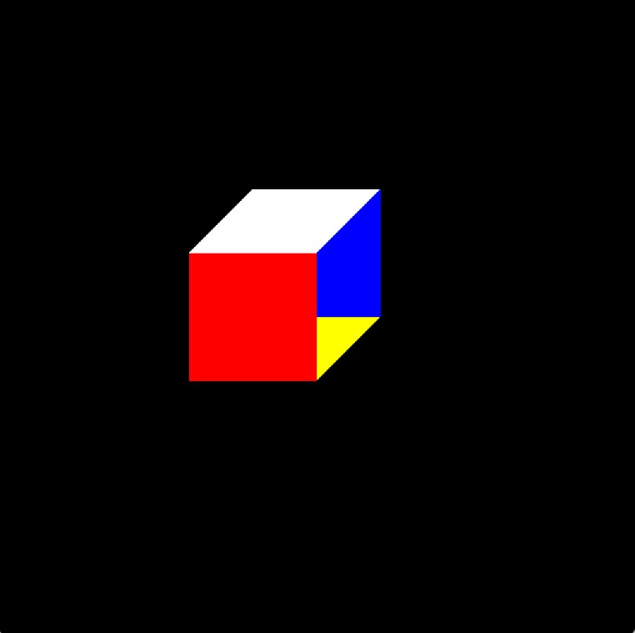 *glVertex3f*(-0.4, -0.2, 0.0); *glVertex3f*(0.0, -0.2, 0.0); *glVertex3f*(0.2, 0.0, -0.4); *glVertex3f*(-0.2, 0.0, -0.4); *glEnd*();

***// Front face (Red)***  *glColor3f*(1.0, 0.0, 0.0);

*glBegin*(GL_POLYGON);

*glVertex3f*(-0.4, -0.2, 0.0); *glVertex3f*(-0.4, 0.2, 0.0); *glVertex3f*(0.0, 0.2, 0.0); *glVertex3f*(0.0, -0.2, 0.0); *glEnd*();

*glFlush*(); ***// Render the scene***

}

void *display*(void) { *createCube*();

}

int *main*(int argc, char*\*\** argv) { *glutInit*(&argc, argv);

*glutInitDisplayMode*(GLUT_SINGLE | GLUT_RGB); *glutInitWindowPosition*(500, 500); *glutInitWindowSize*(500, 500); *glutCreateWindow*("Cube of IT23226128");

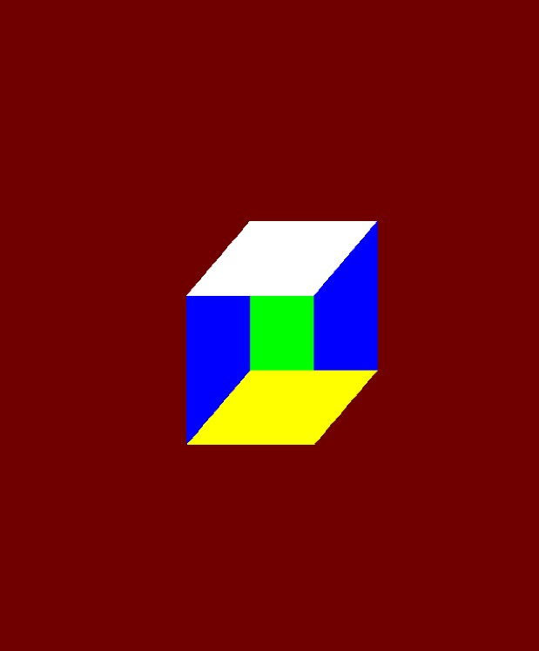 *glClearColor*(0.0, 0.0, 0.0, 0.0);

*glutDisplayFunc*(*display*); *glutMainLoop*(); *return* 0;

}

# Activity 02

#*define* *GL_SILENCE_DEPRECATION*

#*include* <GLUT/glut.h>

#*include* <OpenGL/gl.h>

#*include* <OpenGL/glu.h>

#*include* <stdlib.h>

void *createPyramid*() { *glClear*(GL_COLOR_BUFFER_BIT);

*// Base (Square - using two triangles)* *glColor3f*(0.5, 0.5, 0.5);

***// First triangle of base***

*glBegin*(GL_TRIANGLES);

*glVertex3f*(-0.5, 0.0, -0.5); *glVertex3f*(0.5, 0.0, -0.5); *glVertex3f*(-0.5, 0.0, 0.5); *glEnd*();

***// Second triangle of base***  *glBegin*(GL_TRIANGLES);

*glVertex3f*(0.5, 0.0, -0.5); *glVertex3f*(0.5, 0.0, 0.5); *glVertex3f*(-0.5, 0.0, 0.5); *glEnd*();

***// Front face (Red)***  *glColor3f*(1.0, 0.0, 0.0);

*glBegin*(GL_TRIANGLES);

*glVertex3f*(-0.5, 0.0, -0.5); *glVertex3f*(0.5, 0.0, -0.5); *glVertex3f*(0.0, 1.0, 0.0); *glEnd*();

***// Right face (Green)***  *glColor3f*(0.0, 1.0, 0.0);

*glBegin*(GL_TRIANGLES);

*glVertex3f*(0.5, 0.0, -0.5); *glVertex3f*(0.5, 0.0, 0.5); *glVertex3f*(0.0, 1.0, 0.0); *glEnd*();

***// Back face (Blue)***  *glColor3f*(0.0, 0.0, 1.0);

*glBegin*(GL_TRIANGLES);

*glVertex3f*(0.5, 0.0, 0.5); *glVertex3f*(-0.5, 0.0, 0.5); *glVertex3f*(0.0, 1.0, 0.0); *glEnd*();

***// Left face (Yellow)***

*glColor3f*(1.0, 1.0, 0.0);

*glBegin*(GL_TRIANGLES);

*glVertex3f*(-0.5, 0.0, 0.5); *glVertex3f*(-0.5, 0.0, -0.5); *glVertex3f*(0.0, 1.0, 0.0); *glEnd*();

*glFlush*();

}

void *display*(void) { *createPyramid*();

}

void *keyboard*(unsigned char key, int x, int y) { *switch* (key) { *case* 'r': *case* 'R':

*glRotatef*(10.0, 0.0, 1.0, 0.0); *// Rotate around Y-axis* *break*; *case* 'x': *case* 'X':

*glRotatef*(10.0, 1.0, 0.0, 0.0); *// Rotate around X-axis* *break*; *case* 'q': *case* 'Q':

*exit*(0); *break*;

}

*glutPostRedisplay*();

}

int *main*(int argc, char*\*\** argv) { *glutInit*(&argc, argv);

*glutInitDisplayMode*(GLUT_SINGLE | GLUT_RGB); *glutInitWindowPosition*(200, 200); *glutInitWindowSize*(500, 500); *glutCreateWindow*("pyramid – IT23226128");

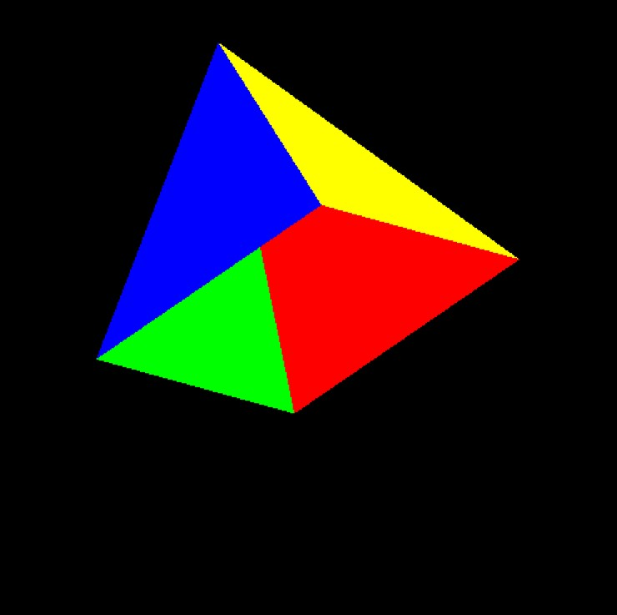 *glClearColor*(0.0, 0.0, 0.0, 1.0);

*glutKeyboardFunc*(keyboard); *glutDisplayFunc*(display); *glutMainLoop*(); *return* 0;

}

# Assignment

#*define* *GL_SILENCE_DEPRECATION*

#*include* <GLUT/glut.h>

#*include* <stdlib.h>

*static* *const* float APEX_PUSH_X = 0.40f;

*static* void *init*(void) { *glClearColor*(0.0, 0.0, 0.0, 1.0); *glEnable*(GL_DEPTH_TEST); *glDepthFunc*(GL_LEQUAL); *glClearDepth*(1.0);

}

*static* void *reshape*(int w, int h) { *glViewport*(0, 0, w, h);

*glMatrixMode*(GL_PROJECTION);

*glLoadIdentity*(); *glOrtho*(-1.0, 1.0, -1.0, 1.0, -1.0, 1.0); *// z in [-1,1]*

*glMatrixMode*(GL_MODELVIEW);

*glLoadIdentity*();

}

*static* void *drawScene*(void) {

*glClear*(GL_COLOR_BUFFER_BIT | GL_DEPTH_BUFFER_BIT);

*// Back face (Green)*  *glColor3f*(0.0, 1.0, 0.0);

*glBegin*(GL_POLYGON);

*glVertex3f*(-0.2f, 0.0f, -0.4f); *glVertex3f*(-0.2f, 0.4f, -0.4f); *glVertex3f*( 0.2f, 0.4f, -0.4f); *glVertex3f*( 0.2f, 0.0f, -0.4f); *glEnd*();

*// Left face (Blue)* *glColor3f*(0.0, 0.0, 1.0);

*glBegin*(GL_POLYGON);

*glVertex3f*(-0.4f, -0.2f, 0.0f); *glVertex3f*(-0.4f, 0.2f, 0.0f); *glVertex3f*(-0.2f, 0.4f, -0.4f); *glVertex3f*(-0.2f, 0.0f, -0.4f); *glEnd*();

*// Top face (White)* *glColor3f*(1.0, 1.0, 1.0);

*glBegin*(GL_POLYGON);

*glVertex3f*(-0.4f, 0.2f, 0.0f); *glVertex3f*( 0.0f, 0.2f, 0.0f); *glVertex3f*( 0.2f, 0.4f, -0.4f); *glVertex3f*(-0.2f, 0.4f, -0.4f); *glEnd*();

*// Bottom face (Yellow)* *glColor3f*(1.0, 1.0, 0.0);

*glBegin*(GL_POLYGON);

*glVertex3f*(-0.4f, -0.2f, 0.0f); *glVertex3f*( 0.0f, -0.2f, 0.0f); *glVertex3f*( 0.2f, 0.0f, -0.4f); *glVertex3f*(-0.2f, 0.0f, -0.4f); *glEnd*();

*// Front face (Red)* *glColor3f*(1.0, 0.0, 0.0);

*glBegin*(GL_POLYGON);

*glVertex3f*(-0.4f, -0.2f, 0.0f); *glVertex3f*(-0.4f, 0.2f, 0.0f); *glVertex3f*( 0.0f, 0.2f, 0.0f); *glVertex3f*( 0.0f, -0.2f, 0.0f); *glEnd*();

*const* GLfloat B1[3] = { 0.0f, -0.2f, 0.0f }; *// front-bottom-right* *const* GLfloat B2[3] = { 0.0f, 0.2f, 0.0f }; *// front-top-right* *const* GLfloat B3[3] = { 0.2f, 0.4f, -0.4f }; *// back-top-right* *const* GLfloat B4[3] = { 0.2f, 0.0f, -0.4f }; *// back-bottom-right*

*const* float cx = (B1[0] + B2[0] + B3[0] + B4[0]) * 0.25f; *// ~0.1* *const* float cy = (B1[1] + B2[1] + B3[1] + B4[1]) * 0.25f; *// ~0.1* *const* float cz = (B1[2] + B2[2] + B3[2] + B4[2]) * 0.25f; *// ~-0.2*

*// Apex pushed outward along +X (to the "right")* *const* GLfloat A[3] = { cx + APEX_PUSH_X, cy, cz };

*// Four triangular sides around the base* *glColor3f*(1.0f, 1.0f, 0.0f); *// Yellow*

*glBegin*(GL_TRIANGLES); *glVertex3fv*(B1); *glVertex3fv*(B2); *glVertex3fv*(A); *glEnd*();

*glColor3f*(0.0f, 1.0f, 1.0f); *// Cyan*

*glBegin*(GL_TRIANGLES); *glVertex3fv*(B2); *glVertex3fv*(B3); *glVertex3fv*(A); *glEnd*();

*glColor3f*(1.0f, 0.5f, 0.0f); *// Orange*

*glBegin*(GL_TRIANGLES); *glVertex3fv*(B3); *glVertex3fv*(B4); *glVertex3fv*(A); *glEnd*();

*glColor3f*(0.6f, 0.2f, 1.0f); *// Purple* *glBegin*(GL_TRIANGLES); *glVertex3fv*(B4); *glVertex3fv*(B1); *glVertex3fv*(A); *glEnd*();

*glutSwapBuffers*();

}

int *main*(int argc, char*\*\** argv) { *glutInit*(&argc, argv);

*glutInitDisplayMode*(GLUT_DOUBLE | GLUT_RGB | GLUT_DEPTH); *// depth + double buffer* *glutInitWindowPosition*(200, 200);

*glutInitWindowSize*(500, 500); *glutCreateWindow*("Cube + Right-Side Pyramid (IT23226128)");

*init*();

*glutReshapeFunc*(reshape); *glutDisplayFunc*(drawScene); *glutMainLoop*(); *return* 0;

}

